**Database II Assignment**

1. Bringing the Table to 1NF

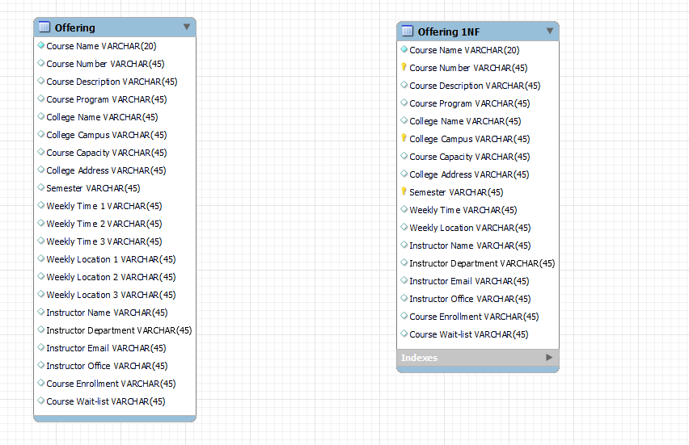

1. The primary key is a composite key made up of ; Course Number, College Campus and Semester columns.
2. **a.**  **Course number**; Course Name, Course Description, Course Program. **College Campus**; College name, College address**. Semester** is a key that helps to uniquely identify each record. Course Enrollment, Course Capacity, and Course waitlist depends on **the three keys**.

**b**. There are partial key violations as there are non-key fields that do not depend on all three keys(composite key), hence prevent the table from going into 2NF.

1. 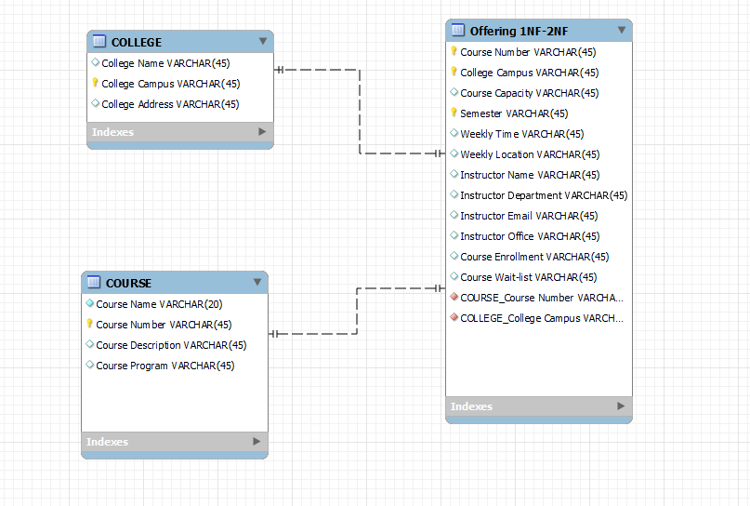
2. **A**. the columns; weekly time, weekly location, instructor name, instructor department, instructor email, instructor office do not depend on the entire **primary key.**

**B.** There are Weekly time, weekly location, instructor name, instructor department, instructor email, instructor office may be used by more than one table.

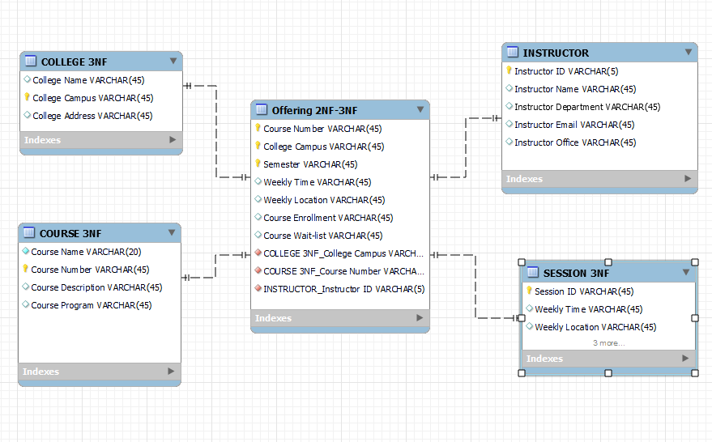

1. I would consider denormalization since there are data not frequently queried form the table.